**PIZZA SALES SQL QUERIES**

1. KPI
2. Total revenue

Select sum(total_price) AS Total_revenue from pizza_sales;

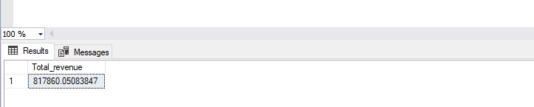

1. Average order value

select sum(Total_price)/count(Distinct order_id) As Average order value from pizza_sales;

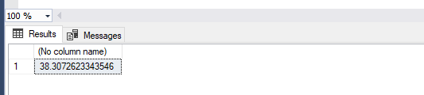

1. Total pizza sold

Select sum (quantity) As Total_pizza_sold from pizza_sales;

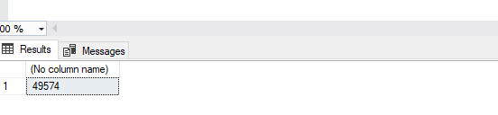

1. Total orders

SELECT count(Distinct order_id) As Total_orders from pizza_sales;

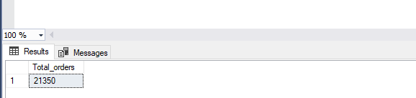

1. Average pizza per order

SELECT cast(cast(sum(Quantity) As Decimal(10,2))/cast(count(Distinct(order_id)) As Decimal(10,2)) As Decimal(10,2)) As Avg_pizzas_per_order from pizza_sales;

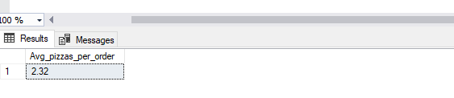

----DAILY TREND------------------

Select DATENAME(DW,order_date) As order_day,count(Distinct order_id) As Total_orders from pizza_sales

GROUP BY DATENAME(DW,order_date)

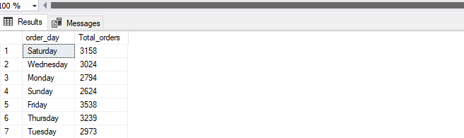

-----HOURLY TREND-------------------

Select DATEPART(Hour,order_time) As order_hours, count(Distinct order_id) As Total_orders

from pizza_sales

GROUP BY DATEPART(Hour,order_time)

ORDER BY DATEPART(Hour,order_time)

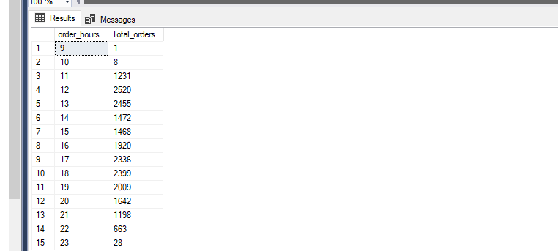

---PERCENTAGE SALES BY PIZZA CATEGORY

Select pizza_category,sum(total_price) as total_sales,sum(total_price)*100/(Select sum(total_price) from pizza_sales

where MONTH(Order_date)=1) As perc_total_sales

from pizza_sales

where MONTH(Order_date)=1

Group by pizza_category

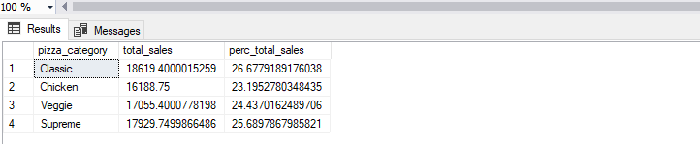

---PERCENTAGE OF SALES BY PIZZA SIZE

Select pizza_size,cast(sum(total_price) As Decimal(10,2)) as total_sales,cast(sum(total_price)*100/(Select sum(total_price) from pizza_sales

where DATEPART(quarter,order_date)=1) As Decimal(10,2)) As perc_total_sales

from pizza_sales

where DATEPART(quarter,order_date)=1

Group by pizza_size

Order by perc_total_sales DESC

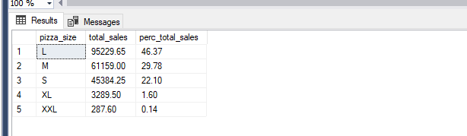

-----TOTAL PIZZA SOLD BY PIZZA CATEGORY--

SELECT pizza_category,sum(quantity) as Total_pizza_sold

from pizza_sales

GROUP BY pizza_category

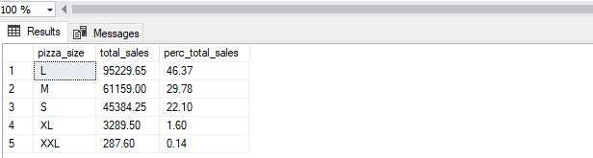

----TOP 5 BEST SELLER BY TOTAL PIZZA SOLD--

Select pizza_name,sum(quantity) as Total_pizzas_sold

from pizza_sales

GROUP BY pizza_name

ORDER BY sum(quantity) DESC

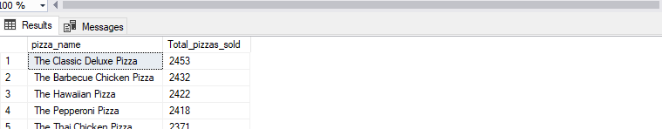

---Bottom 5 pizza sold

Select Top 5 pizza_name,sum(quantity) as Total_pizzas_sold

from pizza_sales

GROUP BY pizza_name

ORDER BY sum(quantity)

